**GITHUB – Connecting to Repository for the first time**

1. Log in to github.com
2. Search for the Repository. Say the repository is “VAT-Gap-Model”

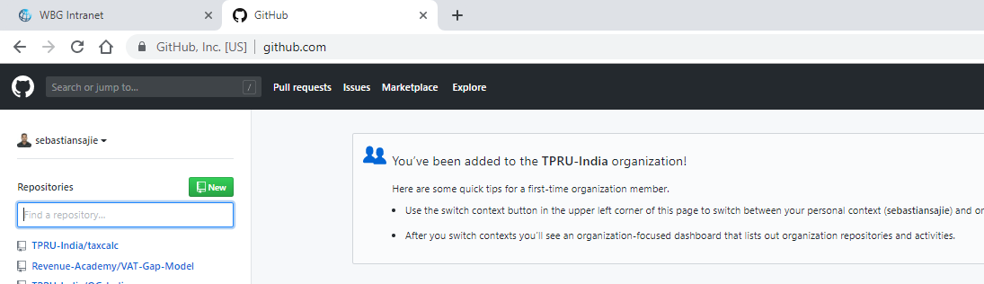

1. Go to repository in github. VAT-Gap-Model is under the organization “Revenue-Academy”

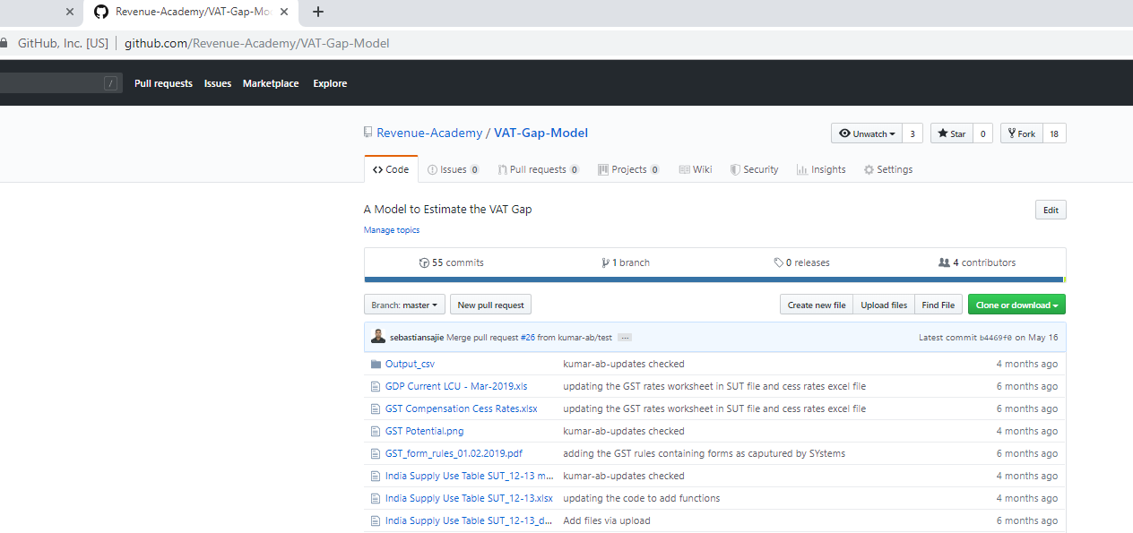

1. Click on the “Fork” button

This creates an online version of the repository under your username (say your username is “sebastiansajie”)

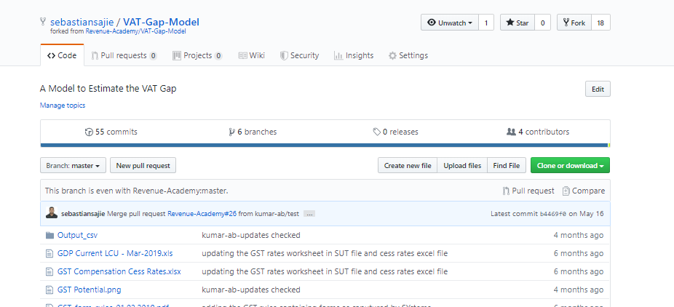

You would now see the webpage with the repository under your name, there will be a Code and other folders

1. Now you will see a button on the webpage – Clone or download. Click on it. It will open up a small window with a path. Click on the icon beside the path shown which copies the link. Alternatively, you may select the path shown in the window and copy it.

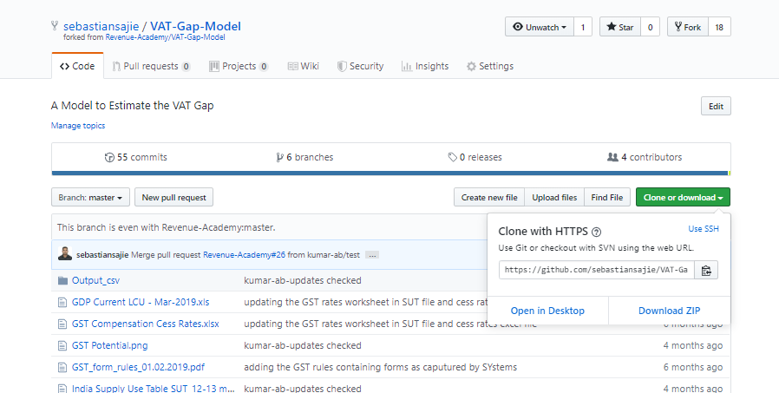

This creates a git file sebastiansajie/VAT-Gap-Model.git

1. Open Anaconda prompt or Command Prompt or Terminal. In the command prompt navigate to the local directory where you want your repository – say “VAT-Gap”

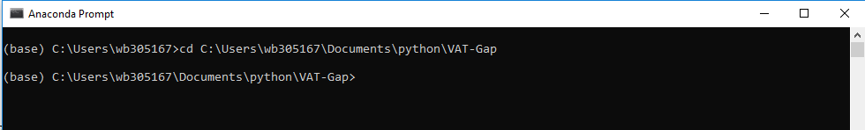

1. Now type

“git clone ” <paste the link you copied above>

This will create a local copy of the repository creating a sub-directory under the name of the repository – “VAT-Gap-Model”

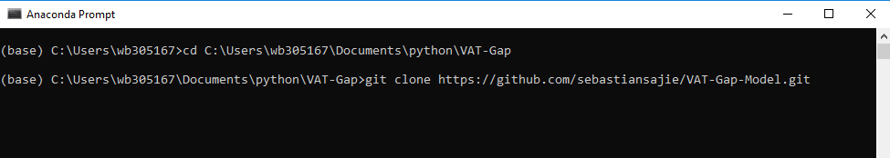

1. Now navigate to the directory that would be created – “VAT-Gap-Model”
2. Check if the local repository is created. In the anaconda prompt window type,

git remote -v

This will show two channels (origin)



This completes the process of creating a local copy of the repository. You can navigate to the directory VAT-Gap-Model and see and access all the files that have been downloaded onto your computer.

Next, we need to create an upstream channel to allow local changes to be reflected in our online repository.

1. Navigate to the main repository in github – not the forked copy. This can be got to by clicking on the link “Revenue-Academy/VAT-Gap-Model” which is below your online copy of the repository



This brings you to the main repository page

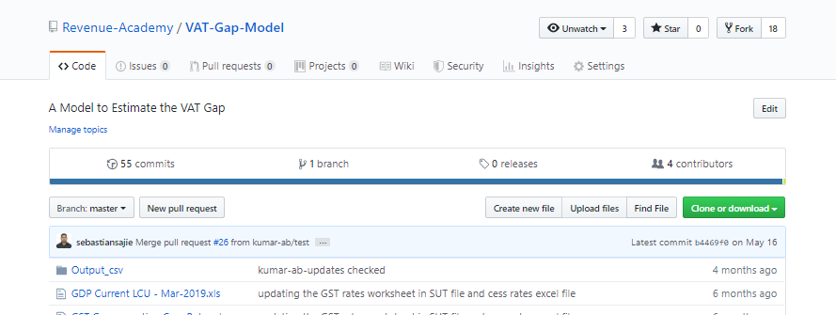

1. We now click on the Clone or download button. This opens up a window with a path. Click on the icon beside the path shown which copies the link. Alternatively, you may select the path shown in the window and copy it.

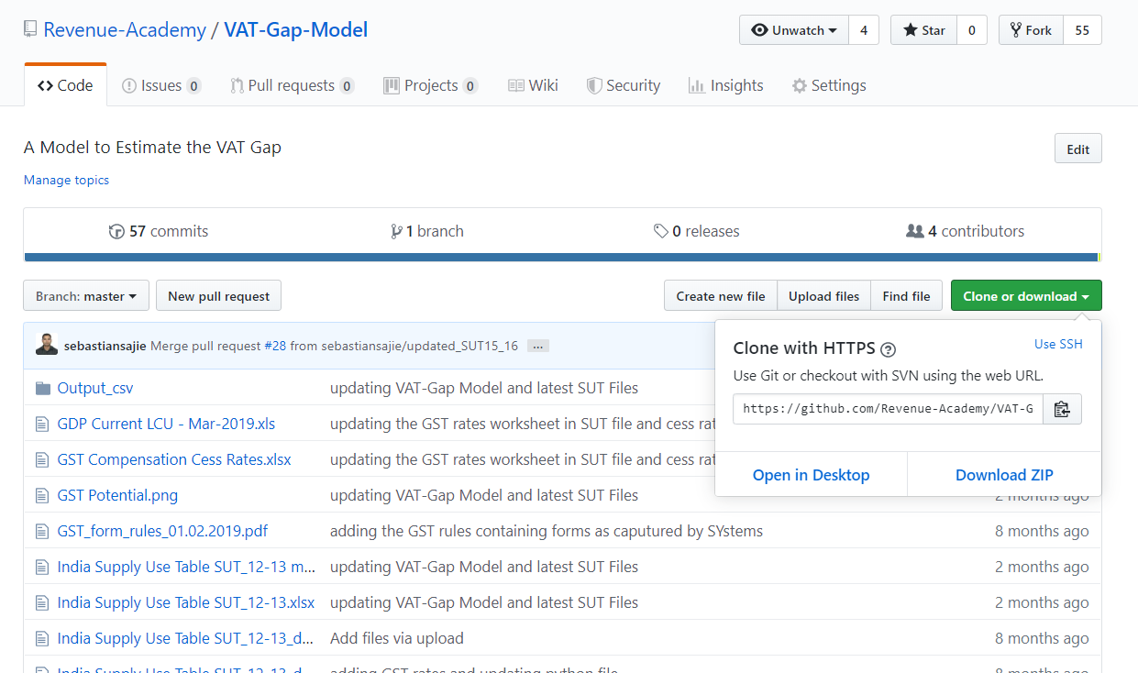

1. Go to anaconda prompt/Command Prompt/Terminal to the folder where the local repository is placed and type

git remote add upstream <paste the link you copied above>

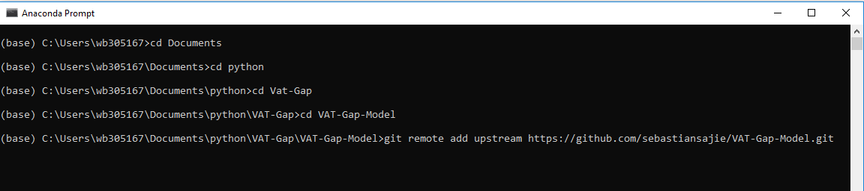

This creates an upstream channel and completes the creation of the local repository and links it to the online repository. The channels created can be verified by typing git remote -v. it would show the upstream as well as origin channels.

